* Container solutions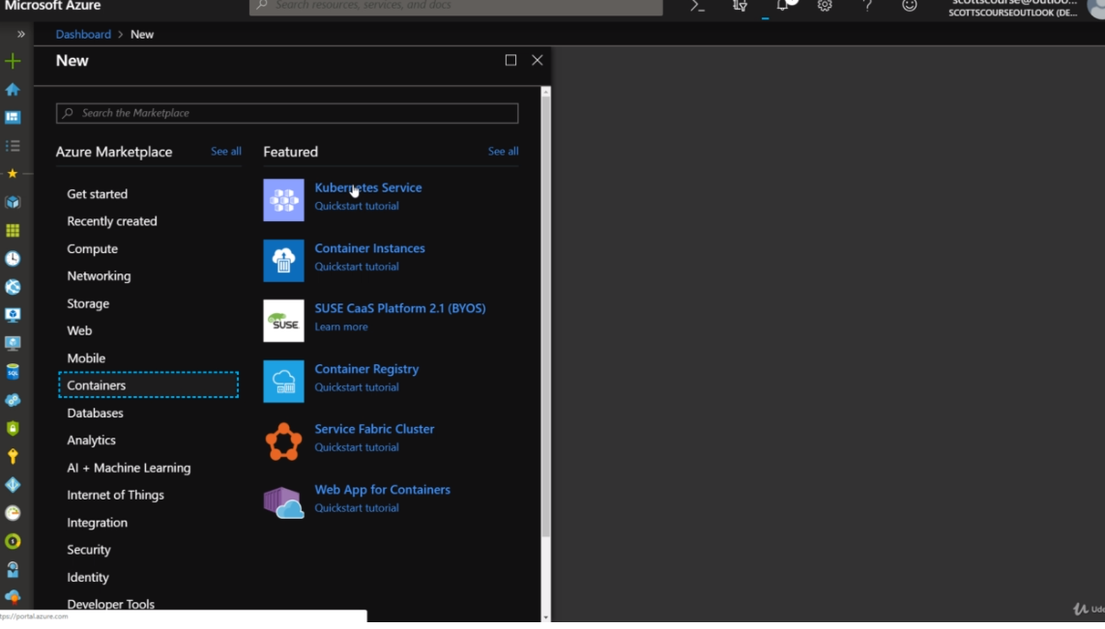
* <https://docs.microsoft.com/en-us/azure/aks/intro-kubernetes>
* Azure Kubernetes Service (AKS) manages your hosted Kubernetes environment, making it quick and easy to deploy and manage containerized applications without container orchestration expertise. It also eliminates the burden of ongoing operations and maintenance by provisioning, upgrading, and scaling resources on demand, without taking your applications offline.
* Creation process: 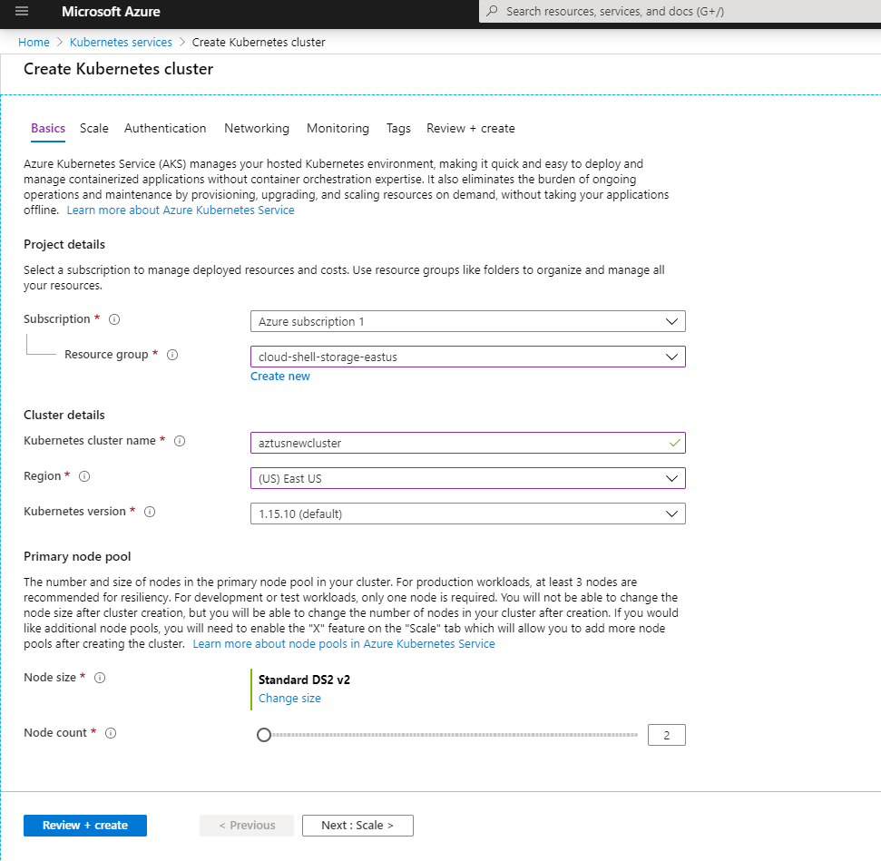
* Clusrwe configs 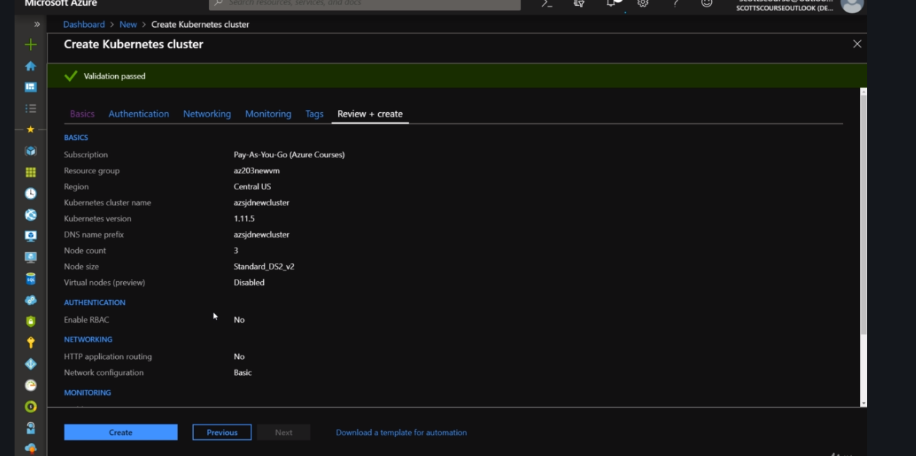
* Get credentials for cluster setup in the azure bash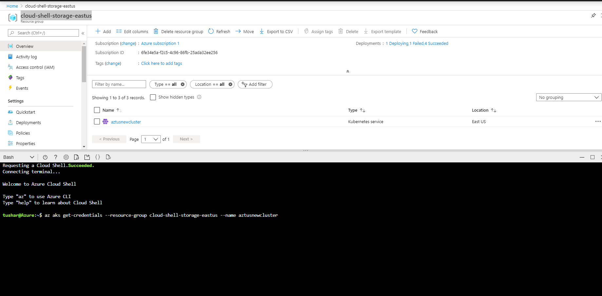
* Will get to see the nodes when the cluster is setup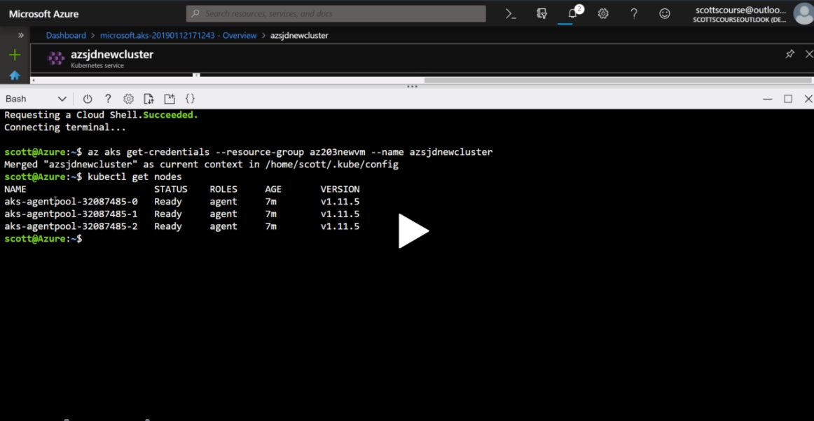
* Deploy test starter yaml file<https://docs.microsoft.com/en-in/azure/aks/kubernetes-walkthrough-portal>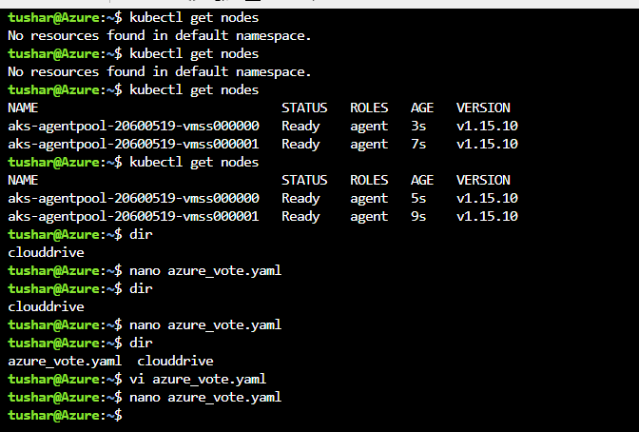
* And then apply the file and then check the services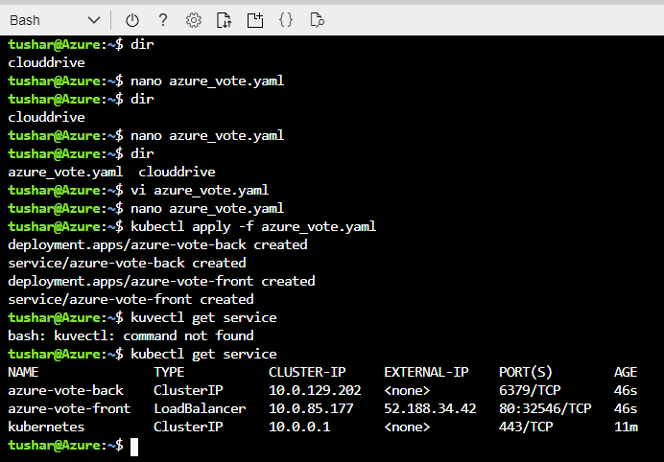

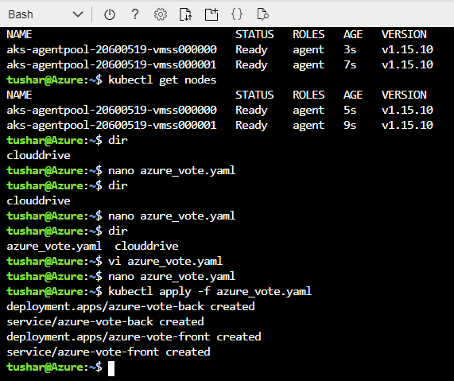

* Frontend code we can access from frontend service External IP Address